Student Activity
22 Ohmic and non-ohmic conductors

TASK
To investigate the properties of an ohmic and a non-ohmic conductor.

THEORY
An ohmic conductor has a resistance that obeys Ohm’s law. That is, its resistance does not vary but is a constant, where V ∝ I. Non-ohmic conductors have a resistance whose value varies when the current or potential difference changes.

EQUIPMENT
• power supply
• connecting wires
• DC ammeter (0–1 A and 0–5 A) or current sensor
• DC voltmeter (0–15 V) or voltage sensor
• rheostat or variable resistor
• approx. 50 cm of nichrome wire laid out straight or taped to a rule
• light globe (6 V) and holder

NOTES ON METHOD
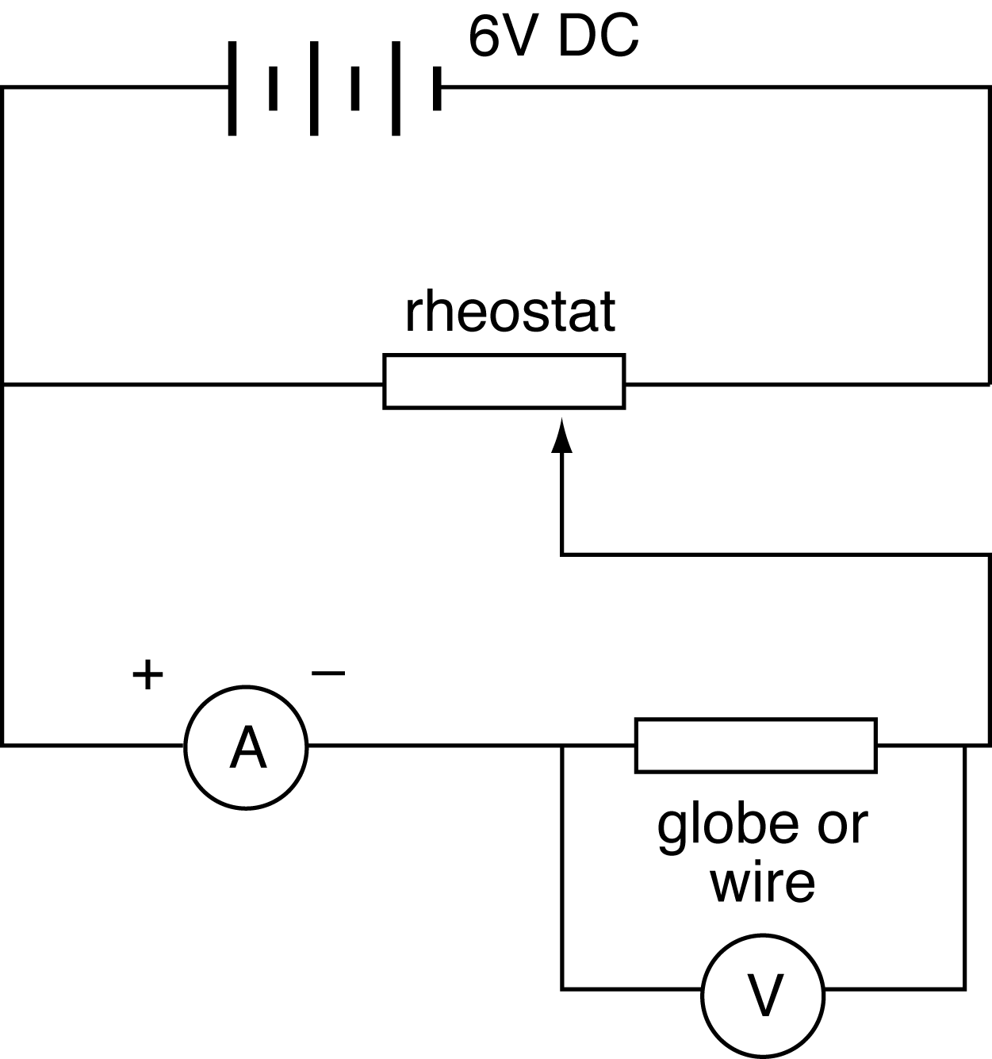

1. Connect the non-variable terminals of the rheostat to the DC terminals of the power supply.
Connect the remainder of the circuit.
The positive terminal of the ammeter should be connected to the positive side of the rheostat.

ICT
Most current sensors have a 1 A range and are suitable for this experiment.
They are generally current-protected, but take care to check the manufacturer’s specifications, and use sensors with care. Exceeding the maximum current rating will permanently damage an ammeter or sensor.
Sample rate: As only comparative values are required, the default rates of your equipment or manual sampling are suitable.
Use a digital display to view and record instantaneous values of current and voltage.
More experienced users may be able to construct a more automated experiment.

2. Connect the voltmeter initially across the globe.
Set the sliding contact of the rheostat near the positive end to produce the rheostat’s lowest resistance value.
Turn the power supply on to 6 V and watch the meters.

3. Adjust the rheostat until a current of 0.2 A is recorded through the globe.
Record the corresponding potential difference across the globe.

4. Using the rheostat, increase the current in steps of 0.2 A.
Note and record the potential difference and current each time.
22 Ohmic and non-ohmic conductors
continued

5. Switch the power supply off and replace the globe in the circuit with a 50 cm length of nichrome wire stretched out reasonably straight. You may find it best to tape it to a rule, but make sure it is not in contact with any other conductor. Turn the power supply back on and repeat steps 3 and 4 for the nichrome wire.

DATA & ANALYSIS
Plot a graph of V versus I for the globe and the nichrome wire on the one set of axes.

CONCLUSION
Based upon your results, are the globe and the nichrome wire ohmic or non-ohmic?
Refer to your graph in justifying your conclusion.

QUESTIONS
1. Determine the value of R for the ohmic conductor from the slope of the graph of V versus I.

